Course Project – Identifying Business Requirements and Key Business Questions

Shaun Pritchard

Rasmussen College

QMB4100

Darice Corey

April 18, 2021

**Course Project – Identifying Business Requirements and Key Business Questions**

I am proposing a new product service for allrecipes.com that would be an integration to the existing platform and new business model of being a social media recipe sharing experience. This new product would allow users to set customized pre-defined meal plans within their user accounts that would accommodate customizable specific calendar time lengths, meal options based on dietary requirements, budget, social trends diets, physical health factors, specific user-defined food ingredients.

The meal plans would be based on categorical recipe data, trend topics, and user input data to meet their specific dietary needs. This product would use available data in Allrecipes.com to pull recipes into the meal plans and customized them to fit the needs of the user. This service would aggregate trending recipes that meet specific user factors into their custom meal plans while implementing new trending and top recipes that meet the user factors as well. This service would open an opportunity to interject ad-based recipes, ingredient advertising, monetization from Allrecipes.com vendors and partners, and open new doors to integrations of APIs that would allow users to purchase ingredients for the recipes through Allrecipes.com.

This objective would also substantiate new Integrations of the platform for health advisors, personal coaches, icons, health instructors, and bodybuilders to share and promote meal plans based on the recipes and meals provided. This could open new marketing segments within the allrecipe.com platform while defining a true digital food and recipe experience unlike any other that exists today. This would also open up new opportunities in data acquisition, trends through recipes and meal plans, and trends that could be used in the monthly print extension of Allrecipes.com magazine.

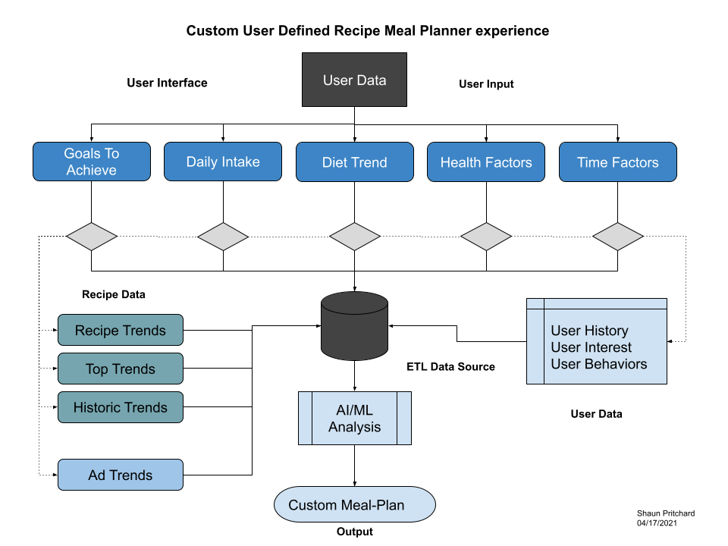

**Identifying Input Factors:**

This product will be contingent upon the input parameters of the user. As described above I have identified 5 factors to contribute as input data to build out user defined meal plans.

1. Goals to achieve(i.e. Health goals, lose weight, gain muscle, Feel better)
2. Daily Intake (i.e. Carbs/calories/sugar)
3. Diet Trend (i.e. Diet trends, Paleo, Adkins, Vegan)
4. Health factors (i.e. Medical issues to watch, allergies)
5. Time factors (i.e. Time, months, weeks, years, days to meet goals)

**Business Requirements:**

In order to substantiate this new service is a new integration to the platform of all recipes. I have acquired several business requirements to facilitate implementation.

* Implement a user A&B testing survey to accommodate the proof of concept
* Track user behaviors, interest, dietary, personal, health requirement data.
* Determine recipe health, ingredient, and source data
* Implement advertising and content marketing relationships between meal plan recipes and user data
* Tracking and analysis of recipes cooks are submitting and sharing content to establish trends and forecasting data.
* Determine user-based Recipe, and ingredients trends and popularity data
* Analyze source ingredient trends data
* Develop project scope and analysis of current allrecipes.com infrastructure and requirement for extending and scaling the Allrecipes.com application.
* Develop a data structure system to process recipes that will best fit the user custom meal plans. recipes can be categorized and clustered to distribute a range of historical and new recipes to facilitate end user engagement through this new application service.
* Distributed paid services option to locked and custom recipes, mael plans, and insights from top cooks, and health advisors, personal coaches, and dietary professionals.
* Develop social sharing functionality and user calendar functionality with options to share meal plans. ( This could aid in acquiring new users to the platform)
* Integrate API for customer user option to purchase in app ingredients for meal plan recipes.

**Business KPI ( Key Performance Indicators)**

Below is important KPI metrics I feel will be necessary to meeting the business requirements of this venture.

* Knowing how consumers interact with branded, recipes, and meal-plans content
* Track user engagement and behaviors
* Track user trends of customized meal plans for content forecasting
* Track recipes and ingredient health data analysis.
* Track popularity trends of recipes both historic and present recipes that meet the requirements of the application service.
* Track the lifetime value of a customer acquisition
* Track conversion rates
* Track user social engagement
* Track client or customer satisfaction and usability.

**Data acquisition:**

To implement this product the need to acquire contextual data and resources including historical categorical, analyzed , trends based on the recipe data, user submissions, ingredients, and health data To meet the requested business requirements and KPI factors we would need data about users, customers, recipes, recipe Health factors, ingredients, and social interactions. The outline data but needs to be readily available or within grasp to be implemented and transformed the proper analysis. With the user data, we could Define interest behaviors and habits of specific users following the recipes that they have engaged with, downloaded, shared, or used. The customer data being specific data in regard to in-app purchases, add sales, and purchases of services and products to identify user behaviors. The recipe health data would be the health facts and information for recipes used to determine dietary preferences. The ingredients data would show quantities concerning the health facts and the social interaction data would be the interactions based off Trends on recipes, cooks, and vendors (API, 2021).

**5 key business questions:**

1. What are the most important immediate outcomes you see for this project?

2. What problems do you see this project solving? What is the evidence of the problems?

3. How does this project support the mission of the department, division, and/or company?

4. How will you know if this project has been successfully completed?

5.What are the major obstacles or impediments to the success of this project?

**Visualization Examples:**

Using data Historic data to determine and analyze top recipes.

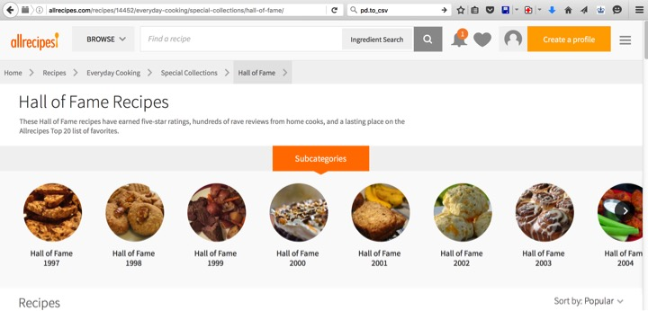

Extracted heath and ingredient data from top recipes



Visualizing ingredient data sources for viable meal plans specific to the *user input factors*

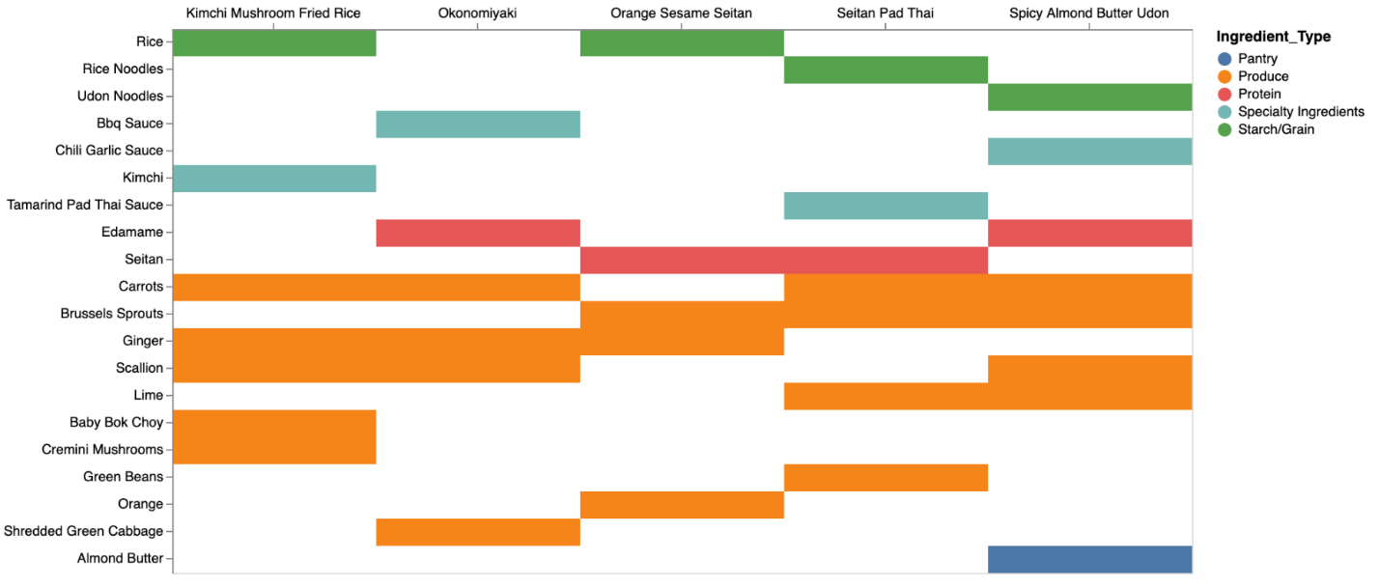

Analysis of user trend data and recipe data from All Recipe.com (Kaggle, 2021).

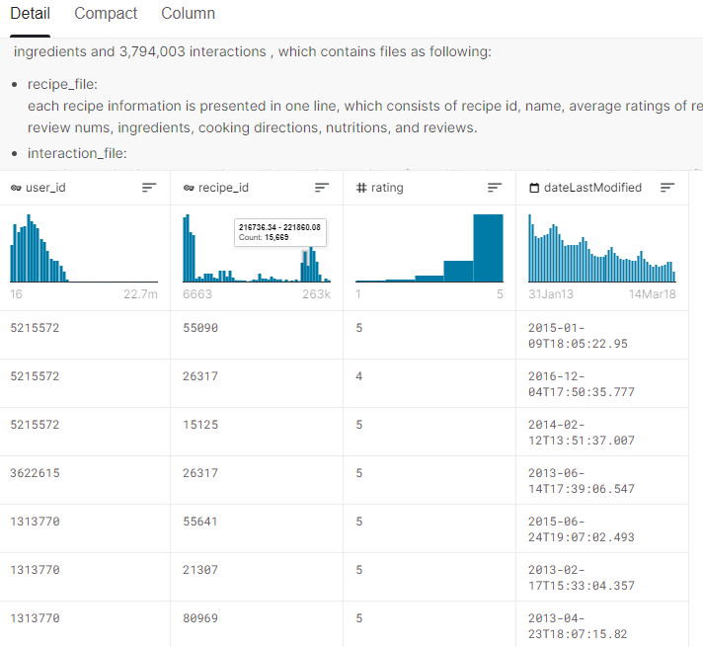

# References

API, M. (2021). *MealPlanner API*. Retrieved from https://www.mealprepapi.com/: https://www.mealprepapi.com/

Kaggle. (2021). *core-data-test_rating.csv*. Retrieved from https://www.kaggle.com: https://www.kaggle.com/elisaxxygao/foodrecsysv1